**1. Selection Sort**

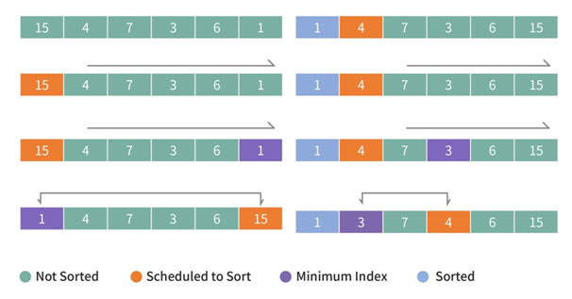

|  |  |
| --- | --- |
| import java.io.BufferedReader;  import java.io.IOException;  import java.io.InputStreamReader;  import java.util.StringTokenizer;  public class Main {    public static void main(String args[]) throws IOException {  BufferedReader br = new BufferedReader(new InputStreamReader(System.in));  //선택정렬  int n = Integer.parseInt(br.readLine());  int arr[] = new int[n+1];    StringTokenizer st = new StringTokenizer(br.readLine());  for(int i=0;i<n;i++) {  arr[i]=Integer.parseInt(br.readLine());  }    selection_sort(arr,n); } | private static void selection_sort(int[] arr, int size) {  // TODO Auto-generated method stub  for(int i=0;i<size;i++) {  int minindx = i;  for(int j= i+1; j<size;j++) {  if(arr[minindx]>arr[j]) {  minindx = j;  }  }  int tmp = arr[minindx];  arr[minindx] = arr[i];  arr[i]=tmp;  }    }  } |

**2. Insert Sort**

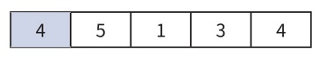(원소가 1개 정렬된 상태)

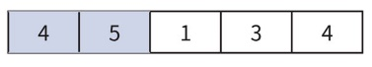(5는 4보다 크고, 다음원소 아직 정렬x)

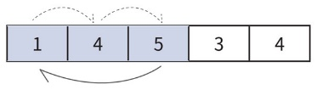(1은 4,5 보다 작기 때문에 첫번째로 들어가고 4,5는 밀림)

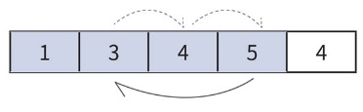(3은 3,4보다 작지만 1보다 크다, 그러므로 1과 4사이에 들어감)

|  |  |
| --- | --- |
| import java.io.BufferedReader;  import java.io.IOException;  import java.io.InputStreamReader;  import java.util.StringTokenizer;  public class Main {  public static void main(String args[]) throws IOException {  BufferedReader br = new BufferedReader(new InputStreamReader(System.in));  //삽입정렬  int n = Integer.parseInt(br.readLine());  int arr[] = new int[n];  StringTokenizer st = new | StringTokenizer(br.readLine());  for(int i=0;i<n;i++) {  arr[i]=Integer.parseInt(st.nextToken());  }  for (int i=0; i<n;i++) {  int temp = arr[i];  int j= i-1;    for(;j>=0;j--) {  if(arr[j]<temp)break;  arr[j+1] = arr[j];  }arr[j+1] = temp; }}} |